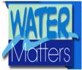
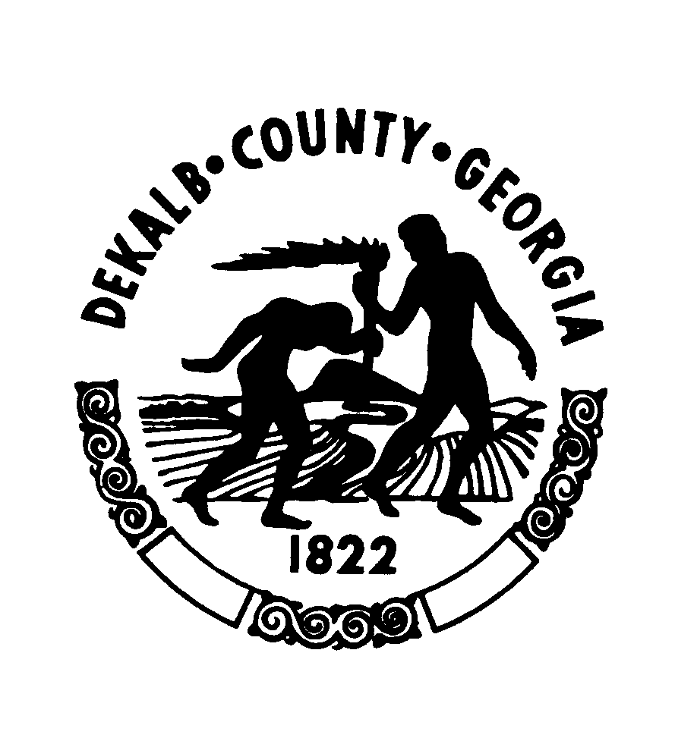
Department of Watershed Management
Operations Division
1580 Roadhaven Drive / Stone Mountain, Georgia 30083

DeKalb County Scott Candler Water Production Laboratory
The Water Production Laboratory is a branch of the Operations Division and their primary function is to conduct all required sampling under the USEPA Safe Drinking Water Act for a large system. Georgia has Primacy from the USEPA and conducts all of the reviews, regulatory investigations and compliance activities through the Environmental Protection Division (EPD). As part of this process the laboratory is required by the Georgia Environmental Protection Division to monitor the water quality of the distribution system of DeKalb County. The lab samples and tests the source water from the Chattahoochee entering the treatment plant and the final treated water as it enters the distribution system. Internal process samples are conducted by the plant operations staff under their licensure as part of the plant process control. Our staff is well educated, experienced, trained and certified individuals who also maintain the lab certification to be able to conduct these tests.
Chemical and bacteria testing are performed daily on the source water. The results of these analyses are used as part of the process control to establish chemical treatment rates. During the treatment process, the water is monitored hourly, 24 hours a day, 7 days a week by the licensed plant operators. Bacteria samples are collected every 8 hours for total coliform and heterotrophic plate count.
Based on DeKalb’s population of around 700,000, the system is required to be sampled in at least 720 distribution different sites. DeKalb currently has 769 sites so that if a site becomes un available anywhere in the County we will not go out of compliance. These sites are required to be sampled every three months to assure a minimum of 240 samples per month. The distribution system is divided into different areas for our sample routes. For example, on Mondays samples are collected in the Dunwoody area, Tuesday is North and Central Decatur, Wednesday is Central and West DeKalb, Thursday is Lithonia and South DeKalb and then Friday is the Tucker area. A total of 65 samples per week are collected routinely Monday through Friday.
The primary focus on this sampling is to check for chlorine residual and total coliform. Chlorine is the residual disinfection chemical we maintain in the system to protect the system from any additional contamination that might occur after the water leaves the plant and before I arrives at your tap for use. Total coliform testing is used to monitor the system for any potentially harmful bacterial contamination that could occur from compromises in the system such as leaks, cross connections or other issues.
This is one level of protection in a variety of measures in place that include backflow control valves at business and industry sites, backflow devices in residential meter sets, operation of a Call Before You Dig location system to help prevent hits on our water lines, construction/building inspectors, plan reviewers, and several hundred employees working in the field who also protect the system. We do have staff for the field 24 hours per day. These components work together to provide a very thorough system to protect our water quality. As part of the sampling tests for pH, fluoride, iron and temperature are conducted.
If a sample tests positive for total coliform, the lab analyst returns to the site to do a resample at that site and also at sites upstream and downstream of the original sample point. The majority of the time all of the resamples are negative for total coliform. Occasionally, the original sample is positive again, but the other samples are negative. In this case, the lab calls the business that had the positive sample to inform them they need to call a plumber to check the faucet. The lab has never seen an instance where all the resamples came back all positive which would indicate a problem in the system.
In addition to the required routine sampling, the lab also samples for main break events or any other situation when there is a possibility of water contamination. The number and area of samples is situational dependent on the size of main break, type of break and the area affected. The production laboratory also samples for new main sterilizations and renewals before these systems are allowed to be connected to the main distribution system. This type of sampling is done as needed when contractors call for an appointment. It takes two consecutive clear samples on separate days for the lines to pass.
The lab is also responsible for handling customer calls and sampling if determined necessary to assist the customer with their water quality concerns. Many of these calls turn out to be aging piping systems in the houses that are leaching iron which causes a discoloration of the fixtures and water in the house, failing hot water tanks which contribute granular forms of water hardness in the plumbing or as simple as air in the water which causes a grey discoloration and clears upon standing.
Annually the lab also puts together the SDWA required Consumer Confidence Report which tells about the water quality for the past year to include any violations that have occurred related to the required elements. This is sent out and placed on our website, DeKalbWateshed.com at this time of year.
Attached to this is a spreadsheet showing the sample results for the Dunwoody area for the first six months of this year.

The map shows the distribution of the sample sites in Dunwoody Corporate limits of the 159 sites in this part of the County we use. We try to use business type sites so we have access to the site at times we need to sample. Residential sites pose access issues for taps that are used frequently enough to refresh the water from the main to the inside tap.
