What should the City of Dunwoody do when a developer wants to rebuild a 100 acre apartment complex? Citizen input is needed on Tuesday.
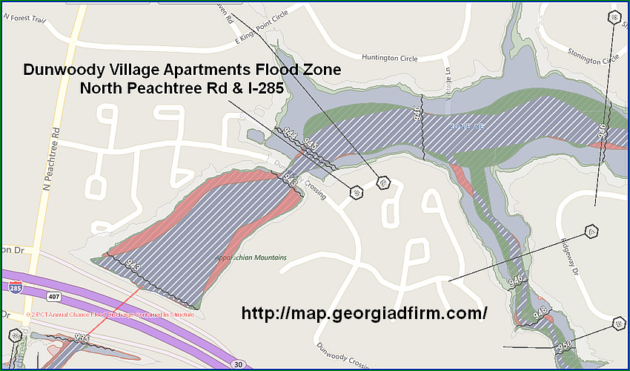
Dunwoody Village / Dunwoody Crossing Apartment Complex
Public Meeting @ Dunwoody City Hall
41 Perimeter Center East
Dunwoody, Georgia
Tuesday December 5th
6:00 pm - 8:00 pm
On Tuesday, December 5th at 6pm at Dunwoody City Hall there will be a meeting to discuss the communities vision and action plan to guide investments and future improvements in areas of the city that are prime for redevelopment. While talking redevelopment, suggestions will also be taken on park, trail and sidewalk opportunities as well as street connectivity improvements in these areas of the city.
In the 2015 Dunwoody Comprehensive Land Use Plan, it recommended that the City undertake a study of the redevelopment potential of these areas to get community input and study the impacts of new development along the I-285 corridor. Therefore the City sent out an RFP and is now in the primary stages with Tunnell - Spangler - Walsh & Associates to conduct this small area study of these properties, but to me, there are only three areas that this study truly explores for economic redevelopment. The first is the large set of apartment complexes at Winters Chapel & Peachtree Industrial Boulevard, the large "Dunwoody Village / Dunwoody Crossing" Apartment complex at North Peachtree Rd & I-285 and finally the corner of Winters Chapel and Peeler which is now dominated by the Walmart Neighborhood Market in the City of Peachtree Corners.
If I was betting man (because of property age, land mass, location and topography challenges), I would bet that the 90 acre "Dunwoody Village" complex along North Peachtree Road & 285 would be one of the first of these properties to come in front the City Council for possible redevelopment. The 2015 Comprehensive Land Use Plan envisions the aging, existing multi-family apartments currently zoned RM-100 to redevelop into a multi-family, mixed-use development adding public functional green space and more owner-occupied options including attached & detached single-family homes.
The community, after numerous meetings, stated that the vision for the area should provide high-density housing options along I-285 with high-quality material and amenities that are contextually sensitive to the surrounding land uses. Strong continuity between developments through high architectural standards, quality building materials, prominent placement of amenities such as functional green space and pedestrian walkways and bicycle paths. Transitional buffer zones will appropriately protect any adjacent single-family residential whereby transitions include gradual increases only in height-plane, buffers and landscaping and intensity of uses.
This development of numerous two-story apartment buildings built in 1981 is split into four different parcels (1, 2, 3 & 4) which appears to be last purchased as a group in 2014 for almost $83 million dollars. Looking carefully at the various maps, you will notice that there is a flood plain that dissects this large parcel into two haves with the creek running between it. The topo maps show that the front half is flatter than the back half, therefore, there will be challenges in the development, especially if we wanted to save the many trees on the property as the comp plan states that future developments should incorporate sustainable building and site development practices. The creek area is pretty unbuildable therefore there could be dedicated park and path opportunities.
Someday the owner or a future developer will decide that the current apartments cannot be rented at a rate to cover costs, therefore, they will want to sell off or redevelop the property. The current development rights are to build the same number of replacement units but because of the cost of the land the developer would probably want to increase the number of units per acre (which the city council may or may not agree to) and/or find a plan for the land that the community, in general, could support. Mixed use is a possibility that was opened up for the Dunwoody Village / Dunwoody Crossing apartment complex on North Peachtree in the last comprehensive land use update whereby there are typically shops on the ground floor and apartments or condos above - think about the area near the Super Target in Dunwoody or the Costco in Brookhaven - that is mixed use.
Another option for the multi-family, mixed use for the large tract could be a residential area in the back of the complex (past the creek) with a condo tower for those who want to downsize as empty nesters, master on main townhomes & single-family units built where the current buildings are to preserve the trees, then maybe a mix of apartments as you move to the front. The front could have a grocery & drug store, restaurants and other neighborhood shopping. Who knows maybe the gas station on the corner could be brought in to the development to include more commercial space (a Starbucks?) besides a gas station on every corner.
The Mayor and members of the Dunwoody City Council don't have the answers as to the communities desires on what would be acceptable level of redevelopment on these large tracts of land when they come in front of us for possible changes. We can hold the line on development, density and land use within the scope of law but we need to know the communities desires of what to do when developers come knocking with suggestions. Protecting the adjacent single-family residential neighborhoods abutting these properties are goals for the city but that being said, if you live adjacent to these complexes I highly recommend that you become informed and voice your opinion.
This published meeting is intended to establish a community-based vision and action plan to guide investments and improvements within the Study Areas and I can publicly state that I am not aware of any plans to currently redevelop these properties - we are only trying to be proactive as the 2015 comp plan update requested that we do.
Please plan to attend the public Kick-off Meeting on Tuesday, December 5th 6:00 p.m. at Dunwoody City Hall (41 Perimeter Center East, Suite 103 Dunwoody.)

Source – Heneghan’s Dunwoody Blog http://dunwoodynorth.blogspot.com/

