Dunwoody
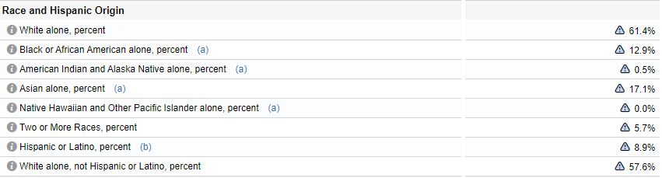
Brookhaven
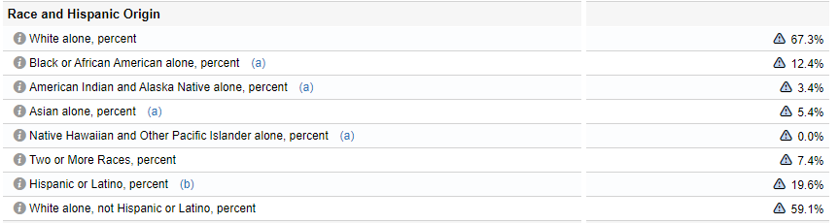
Sandy Springs
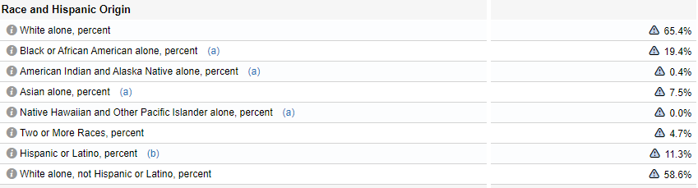
Johns Creek
