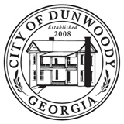 | AGENDA  DUNWOODY CITY COUNCIL  SPECIAL CALLED MEETING  MARCH 23, 2023 - 8:00 AM  FORREST HILLS RESORT  CONFERENCE CENTER  135 FORREST HILLS ROAD  DAHLONEGA, GEORGIA 30533

DUNWOODY CITY COUNCIL SPECIAL CALLED MEETING

- RECONVENE

- 2023 STRATEGIC PLANNING DISCUSSION

- EXECUTIVE SESSION - FOR THE PURPOSE OF LEGAL, REAL ESTATE, AND PERSONNEL DISCUSSION

- ADJOURN

